DUPLICATING DNA

DNA tells cells how to make proteins. The instructions for making proteins are coded for in the sequence of nitrogenous bases in DNA.

These instructions are transcribed into another type of nucleic acid called RNA (ribonucleic acid) in a process called transcription. This RNA copy then moves to a ribosome in the cytoplasm where the genetic message is translated into a protein.

Its nucleotides are different from those of DNA. RNA contains the sugar ribose (instead of deoxyribose), and uracil (instead of thymine) is one of its nitrogenous bases. It is also shorter and single-stranded.

Transcription

The first step in making a protein involves the unzipping of the gene’s DNA. The process of making a copy of the DNA message is called transcription.

When the relevant part of the DNA strand is exposed, a special copy of the sequence is produced in the form of messenger RNA (mRNA).

Messenger RNA (mRNA) passes through the pores of the nuclear membrane into the cytoplasm to take its genetic copy of the protein instruction message to ribosomes.

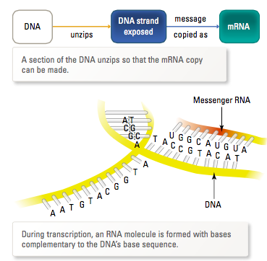

Translation

Once the mRNA has reached the ribosome, its message needs to be translated into a protein.

The ribosome and another type of molecule called transfer RNA (tRNA) are involved in this process.

tRNA located in the surrounding cytosol collects and transfers the appropriate amino acid to its matching code on the mRNA.

These amino acids are joined together by peptide bonds to make a protein.

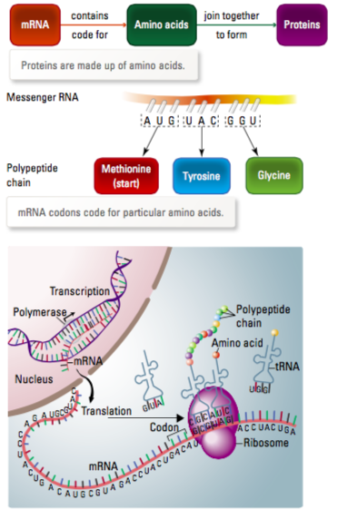

The table below shows some of the codons used by mRNA during translation.

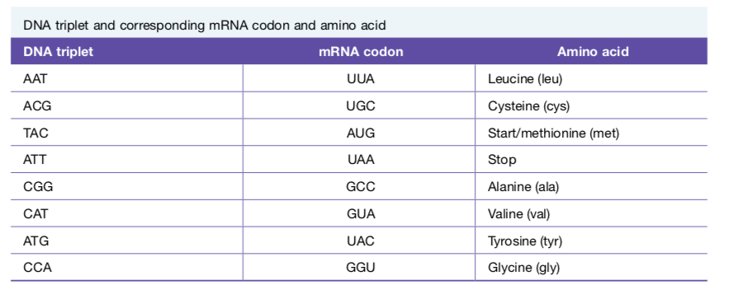

Switched on or off?

Different genes are responsible for different characteristics, such as the colour of flower petals, the markings on a snail shell, or a person’s blood group or eye colour.

Every body cell in an organism has the same set of genes called a genome, but not all genes are active. Some have to be switched on to act and some have to be switched off at different stages in the life of a cell.

e.g. This is why hairs do not grow on the stomach lining and cheek cells do not grow on toenails.

